**Project 1: Unix/Linux Command Line Interpreter**

Kyungchan Im

Grand Canyon University

Course number: CST - 315

Professor Ricardo Citro

Due Feb 12, 2023

**Project 1: Unix/Linux Command Line Interpreter**

This is the project of implementation of the Unix/Linux command line interpreter that within a C/C++ programming. This documentation serves to descriptively explain the features of the command line interpreter, the algorithms used, the program's performance, and an analysis of the program's design. The document will outline five distinct features of the terminal commands. The program is designed to meet several requirements, including the ability to create a child process, enabling the program to run the commands simultaneously when multiple commands are given using the semi-colon separator, running a user created batch file, and terminating program by providing commands. The command line interpreter provided by the operating system is a powerful component of the computer system that allows users to interact with the application using text-based line commands, and this program will perform those tasks above.

**PART 1: Shell Functionality**

For this project, I used C++ built-in system command function for performing the mini shell. There are restrictions on some features, however, system function performed most of the task that can do in terminal shell. Once the program is executed, it will ask user to type either ‘run’ or ‘quit’.

The program has simple user interface to interact with the user easily, once the ‘run’ command is typed, then the program is going to perform terminal shell.

There are four options on the command mode: type command, batch, file, and quit. The user can simply type any command that they want to run. The program will grab the string input from the user. If the command has multiple commands to perform, then the program will divide its commands and run it simultaneously.

When the command ‘ls ; pwd’ is given, the pwd command performed first. The program divided the commands by the semi-colon separator and pushed the ‘ls’ command on wait() statement to perform after ‘pwd’ command.

When ‘batch’ command is given from the user, the program will ask file name, and commands to put within the file. If writing file is done, user can type ‘quit’ to exit. A picture containing text, monitor, screenshot, screen

The file is generated with the given input, and it is saved within the same directory. User can also run a file by giving a ‘file’ command to the program. The ‘file’ function within the program will read line by line inside the file and perform the same task.

Once the name of the file is given from the user, it will print the text inside the file and run a command. The file had ‘ps ; pwd’ commands, so the program executed ‘pwd’ first and ‘ps’ command second.

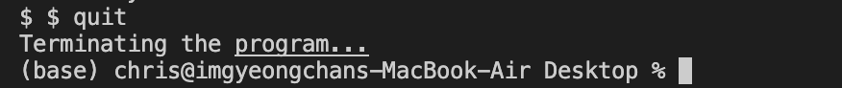

Lastly, when ‘quit’ command is given, the program terminates the command line interpreter. This is general instruction for the program and here’s five features of commands

1. ls

1. pwd



1. ls -l ; touch file

1. ps

1. nano <filename>

The program provides all the general commands except ‘cd’. Since ‘cd’ is only lasts for the duration of the system command. The command starts a separate program, which inherits its current directory from your program, but when that program exits its current directory dies with it. Meaning, this program is not holding the duration of the system command, instead, it is running instantly. Therefore, the change directory will be updated on the next project.

**PART 2: Code Breakdown**

The program will have four functions and one main prompt: splitCommand, runCommand, writeBatchFile, runBatchFile, and main.

The ‘splitCommand’ function take the address value of the string variable as an argument and return the string vector for the output. The function will have ‘const’, so it will have a fixed value. Within the function, there’s vector variable to hold command list, and string variable for user input. The for loop will go through the command character by character until it reads the separator. Lastly, the subcommands will be stored in the vector.

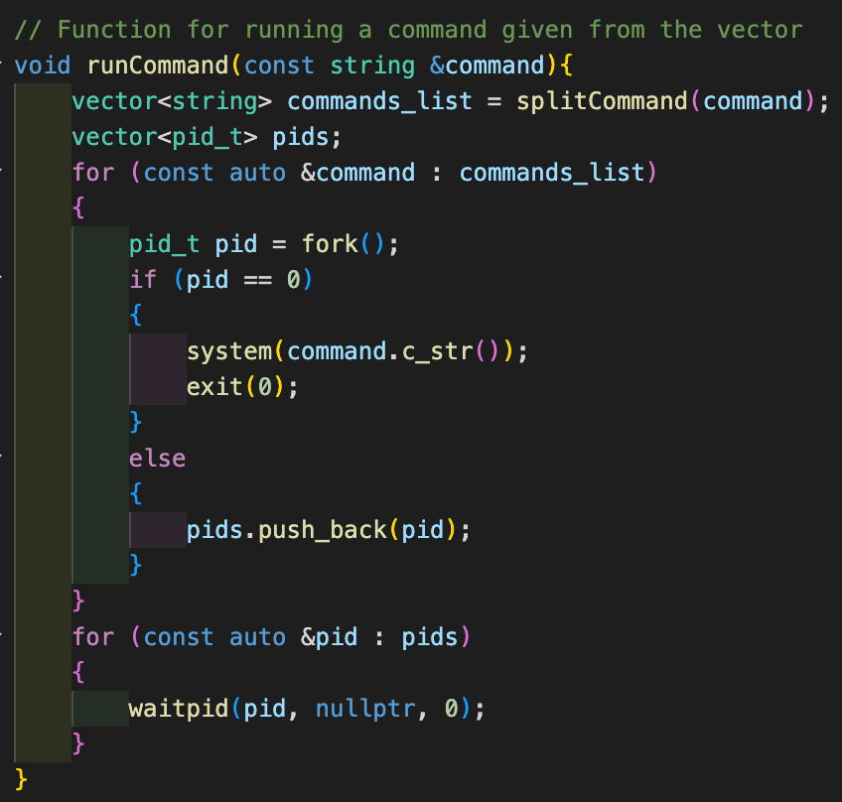

The ’runCommand’ function take the address value of the command string and return nothing. The function will generally execute the logical statement within the scope. The program will take the user input and run ‘splitCommand’, the output for the ‘splitCommand’ is command vector. The commands will be assigned with process id and if the process id is equal to 0, then it is likely to run first.

The ’writeBatchFile’ takes filename as an input and perform the creating and writing file. If user types ‘quit’, then the writing the file is completed.

The ‘runBatchFile’ takes filename as an input and perform the reading of the file. Firstly, it will generate the error message if the filename given is not within the directory. After that, the function will read the file line by line and run the command inside the file.

The main scope has a user interface interaction. It will have a while statement to check the given user input. First stage is going to be asking running a command prompt or quitting the file. If the user types ‘run’, then the program will ask user for several option within the command prompt.

There are four options as I mentioned earlier, and the program flow is within the second while scope.

If and else statement will generate the logical process and once the user input is meeting the requirement for individual command, then it will run the functions above or command.